**Brooklyn torah gazette**

**For Parshas tetzaveh 5779**

Volume 3, Issue 24 (Whole Number 120) 11 Adar Rishon 5779/ Feb. 16, 2019

**Printed L’illuy nishmas Nechama bas R’ Noach, a”h**

For a free subscription, please forward your request to [***keren18@juno.com***](mailto:keren18@juno.com)

**Rav Avigdor Miller**

**On “Be a Hypocrite”**

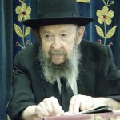

**QUESTION:** How do we create the desire to emulate Hashem's ways when actually we don't have such a desire?

**ANSWER:** Now the first thing is to say to yourself, either quietly or in your mind, "I would like to be *mekayem*walking in the ways of Hashem."

Once you said that, you have to know that you have already made a decisive step in the right direction. It's remarkable what making a decision with words can mean. Just say, "I want to be *mekayem*loving the Am Yisroel like Hashem loves them." Once you say that, you should know that you have made a very important step in life.

Only that you're not going to do it, that's the trouble. But if you would however, then Hakadosh Baruch Hu says,  "You made one step, so I'll give you a big push," and you'll be surprised how far you'll go ahead.

What does that mean? - "You should make yourself holy, - And you will become holy." It's a principle. - "If a man makes himself *kadosh*a little bit then Hakadosh Baruch Hu makes him *kadosh*very much."

It's a very important principle, and this principle you'll find everywhere in the Torah, look at your *tzitzis*, and you'll remember It's a *bris*, it's a promise and you do the *mitzvos,* and you'll become holy. By doing *mitzvos*you'll become *kadosh*.

 How do you become *kadosh*by doing *mitzvos*?  The answer is Hakadosh Baruch Hu rewards you.  So once you'll start in the right direction, then from then on Hashem helps you.  Of course, if you start with a bigger amount of energy, He'll give you a bigger push, but in general that's the way to do it.

So the very first step you have to know is the step of a hypocrite. You don't mean it. But you shouldn't care about that. Do it anyhow. Be a hypocrite. Say, "Hashem I love You." Now, actually you don't love Hashem. It's true that you don't. You love ice cream, that you love. You love cake. You love watermelon.  But Hashem? Say it anyhow! "I love You Hashem."

Realize that you have made a very big step in your life if you say that. A very big step! And most people never said it once in their lives. So when you walk out of here tonight don't lose the opportunity. Nobody should listen.  Say," I love You Hashem." Say that. It's a tremendous achievement. Once in your life you said that, and you don't know what the consequences could be.

And therefore you always must start out in an insincere way; but at least you started out.  And then Hakadosh Baruch Hu takes over.

*Reprinted from the February 4, 2019 email of Toras Avigdor adapted from Tape #870.*

**How Do We Get**

**Super Powers**

**By Rabbi Moshe Meir Weiss**

The Alshich HaKodesh, the Holy Alshich, Zt”l, Zy”a, asks a penetrating and fascinating question. When Moshe Rabbeinu was born, Yocheved was frightened that the Egyptian death squads would confiscate him and throw him in the Nile. The Torah informs us that she constructed a little ark made from bulrushes; she coated it with mortar and pitch and put it in the reeds at the Nile’s edge.

The commentators first point out that the reason she used bulrushes was not only because it was durable, pliable and lightweight, but also because it was the perfect camouflage to blend in with the reeds at the edge of the Nile. Her plan, in putting Moshe there, was two-fold. Firstly, the last place they would look for him would be in the Nile itself.

Secondly, she hoped that by putting him in the Nile, the Egyptian astrologers would see in the stars that the Jewish savior was already drowned and therefore they would cancel the decree to drown the babies. (This was what actually did occur.) Little did she realize that Hashem would cause the ark to float out 400 cubits so that the daughter of Paroh would discover and retrieve him, and raise him royally in the palace of Paroh.

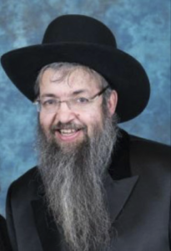

**Rabbi Moshe Meir Weiss**

Now, here is the question of the Alshich: the Torah is very specific in informing us that it was Yocheved herself who built the ark, coated it, and took it, dodging the Egyptian killers, and placed it in the reeds. Where was Amram, her husband, the Godol HaDor? Why didn’t he help in the ark’s construction? After all, that’s more a man’s thing rather than the job of Yocheved who was 130 years old at the time. Why didn’t Amram do the very risky exercise of putting Moshe in the Nile, an action that could have gotten Yocheved arrested and worse? It’s a powerful question, but his answer is even better than the question.

The Alshich explains that Amram’s wife Yocheved was also the midwife, Shifra, who defied Paroh and saved the Jewish babies. Amram wanted that the hand that saved the Jewish babies should construct the ark and place Moshe Rabbeinu into the Nile. He felt that those hands had a special merit and were more likely to deserve saving their son.

What a lesson! Yocheved had what we call in Yiddish gebentchta henteh, blessed hands. There is a Chassidic custom that when a chossid opens up a store or a business, he asks the Rebbe to come and put up the mezuzah. I wondered about the custom.

After all, the Gemora says, “Mitzvah bo yoser mi b’shluchoh – The mitzvah is more upon the one who has the responsibility than upon his agent.” Since the store owner has the requirement, isn’t it preferable that he should put up the mezuzah? However, in light of this Alschich, we can understand this custom. The Rebbe’s hand that saves people with his blessings and care are especially suited to put up the mezuzah which protects and saves the occupants of the store or home.

This teaching has broad applications. Our sustenance is referred to in the Gemora as maaseh yodai’im, our handiwork. If we stretch out our hands often to give charity, it is more likely that those hands will prosper in making a livelihood. On the other hand (no pun intended), if we strike our child unfairly or we decline a poor person’s overtures, then our hands are certainly not blessed. The hands of a mother that lovingly bathes a child and prepares the food for Shabbos, while thinking holy thoughts, and sets out her husband’s clothes with feelings of endearment, those hands are invested with special powers.

This concept, is of course not relegated to the hand. Feet that walk multiple times on Shabbos, to shul and shiurim. Ears that listen to lectures, or to the troubles of the lonely, the childless, the sick. A mouth that speaks warmly and soothingly to loved ones, that davens with concentration and speaks about the Holy Torah, and that sings zemiros on Shabbos.

These orfices and limbs have special powers. May Hashem bless us that we should be able to supercharge our 248 limbs and in that merit we should be blessed with long life, good health, and everything wonderful

*Reprinted from the February 5, 2019 website of Matzav.com.*

**The Eternal Lesson of**

**The Daily Incense Offering**

**From the Talks of the Lubavitcher Rebbe**

**Rabbi Menachem Mendel Schneerson, Zt”l**

In this week's portion, Tetzave, the Torah states: "Aaron shall burn incense each morning when he cleans the lamps. And he shall burn incense in the evening when he kindles the lamps." What purpose did the burning of incense serve in the Sanctuary, and later, in the First and Second Holy Temples? Furthermore, what can we learn from this to apply in our daily lives?

First of all, it is important to note that the command to build the incense altar and bring its offering are mentioned in the Torah as the final elements in the construction of the Sanctuary. In fact, the Divine Presence did not rest in the Sanctuary until the incense offering was brought.

What is the reason for this uniqueness? Our Sages explain that the sacrifices offered on the altar in the courtyard of the Sanctuary relate to a Jew's body, while the incense offering brought on the inner altar relates to a Jew's soul.

This concept is reflected in the Hebrew names used to describe these different offerings. The Hebrew word for "sacrifice" is korban, which has it root in the word "karov," meaning "close." In contrast, the Hebrew for "incense" offering, ketoret, relates to the root ketar, Aramaic for "bond." By bringing a sacrifice, a Jew draws close to G-d. Through the incense offering, however, a Jew and G-d become fused in total unity.

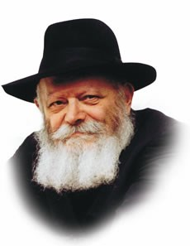

**The Lubavitcher Rebbe, zt”l**

Thus, it is only after the Torah describes the preparations necessary for the Sanctuary, whose purpose is to make it possible for the Divine Presence to dwell among--and thus within--the Jewish people, that it mentions the incense offering, which allows for a bond of oneness to be established between them.

This theme of oneness is also reflected in the dimensions of the incense altar, which measured one cubit by one cubit. Likewise, when the incense offering was brought, the priest making the offering was alone with G-d. No one else was allowed to assist.

These concepts must be paralleled in our daily service of G-d. Every day, a person arises as "a new creation." Every day, therefore, we must renew our inner bond with G-d as expressed by the recitation, in our daily prayers, of the verses concerning the bringing of the incense offering, and how that offering was brought in connection with the cleaning and the kindling of the Menora.

This teaches us that the bond between us and G-d must be extended into our worldly affairs, causing them to be carried out in the spirit of "All your deeds shall be for the sake of Heaven," and "Know Him in all your ways."

*Reprinted from the Parashat Terumah 5773/1992 edition of L’Chaim Weekly, a publication of the Lubavitch Youth Organization in Brooklyn, NY.*

**The Shmuz on****Parshas Tzaveh**

**HASHEM and Man:**

**Master and Servant**

**By Rabbi Bentzion Shafier**

**Founder of TheShmuz.com**

“*The Kohain shall don a garment of linen, and he shall don linen breeches on his skin, and he shall remove the ashes.*” — Vayikra 6:3

One of the daily activities in the Mishkan was **taking out the ashes**. The Chovos Ha’Levavos explains that HASHEM commanded Aaron to do this action each day “to lower himself and rid himself of the arrogance in his heart.”

This statement seems to imply that Aaron was arrogant, and that HASHEM felt he needed specific work to get rid of that sense of superiority. The problem with this is that it is difficult to imagine that Aaron Ha’Kohain was a haughty individual. This concept becomes even more problematic when we focus on the Torah’s description of Aaron.

**A Man of Sterling Character Traits**

When HASHEM appeared to Moshe and said, “I want you to lead the Jewish people out of Mitzrayim,” Moshe refused. He was afraid that Aaron would feel slighted. Up until that point, Aaron had been the leader of the nation, the one who brought the word of HASHEM to the people. Now his younger brother, unheard of for sixty years, would usurp that position. As great as Aaron was, Moshe knew that he was still human and would feel the pain of being displaced. Therefore, Moshe wanted no part of it.

HASHEM explained to Moshe that while this might be a well-founded fear in regards to the average person, because of Aaron’s great spiritual stature, he was above jealousy and competition, and this wouldn’t cause him any pain. He had so eliminated bad character traits from his heart that he would feel nothing negative. In fact, when Moshe assumed this position and Aaron set out to meet him, the posuk says, “It was with **joy in his heart**.”

HASHEM was telling Moshe was that Aaron was in a different category of people. He had mastered his nature. He was like a moloch in human form.

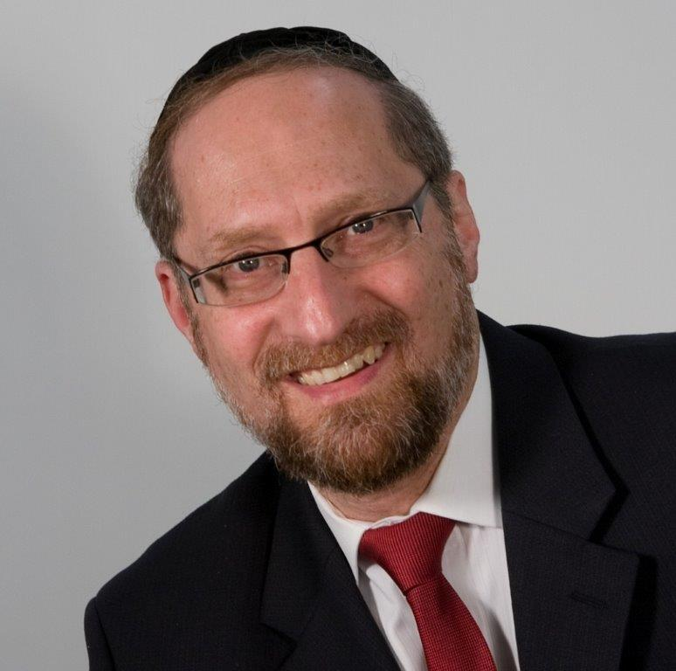

**Rabbi Bentzion Shafier (The Shmuz.com)**

Of all men, Aaron wouldn’t be haughty and overbearing. So why did HASHEM feel that it was necessary for him to take out the ashes each day to eliminate arrogance from his heart?

The answer to this question is based on understanding the underpinnings of our relationship with HASHEM.

**A Servant Needs a Master**

**And a Master Needs a aervant**

The Chovos Ha’Levavos (Shaar Ha’chnah) explains a basic truism: a servant needs a master, and a master needs a servant. By definition, a servant can’t be a servant without a master, and a master can’t be a master without a servant. They are mutually dependent. With that, he explains the danger of arrogance.

The arrogant person feels powerful, mighty, and independent. These are not the traits that one finds in a servant; quite the opposite, these are the traits of superiors, people who rule. These are the traits of the master. For that reason, the arrogant person can’t be a servant of HASHEM.

HASHEM alone has the right to wear the trait of Ga’avah. He alone is mighty, He alone is powerful, and He alone is independent. Anyone else who harbors these thoughts in his heart is “wearing the King’s robes.” He views himself in a manner that is false and delusional.

More significantly, in that state, he cannot serve HASHEM. “How can a person as mighty, significant, and important as I possibly have a master? I am the master!” For this reason, arrogance utterly skews the relationship of man to his Creator. Its opposite, humility, is central to all Avodas HASHEM.

This seems to be the answer to the question. In no sense was Aaron haughty or overbearing; he was amongst the most modest of men. The problem was that his role required even more. As the representative of the nation, he was going into the Holiest of the Holies; any imperfection in his intentions would have spelled an imperfect avodah, so he needed to be perfect in his humility. To attain that state, he needed a physical exercise.

He had to, so to speak, **take out the** **garbage** each day. By doing this, any trace of independence was eliminated from his heart, and he was able to reach that most elusive understanding: I am utterly, completely, and totally **dependent** upon HASHEM. I am the creation, and He is my Creator. As great as Aaron was, he still needed improvement in this area, and it was only through concrete, physical actions that he could reach a state of true humility.

**Humility is the Core of Being an Eved HASHEM**

This concept is very applicable in our lives. All of our avodas HASHEM hinges upon accepting HASHEM as our Master. While we may not be haughty, unless we have worked on acquiring humility, there will be trace elements of arrogance in our hearts, and these will greatly impede our being subservient to HASHEM. They stop us from standing as servants in front of our Master.

The only way to achieve true humility is by being exposed to life situations that allow us to grow in humility. By being subjected to the various situations in life, where we come to recognize that we are not mighty, powerful, and independent, the reality starts to seep in. I am a mere mortal. Here for a few short years, unable to even control my own existence, I am but a creation dependent upon my Master for my very existence.

To help us grow, HASHEM will often custom-tailor situations for us. Not every circumstance in life is pleasant, and not every condition is something would we wish for. Some situations may be demeaning. It may feel like you are being asked to take out the garbage.

You might even feel indignant. “HASHEM why are You subjecting me to this? What have I done wrong to deserve this?” The answer may well be nothing. It wasn’t something wrong that you did that brought this about. Rather, it was something you did **right**, some merit that you have that allowed you to have this opportunity to acquire that rare commodity – humility.

Recognizing our need for situations that bring us to a sense of dependence upon HASHEM can help us understand life, and then we can use these situations to grow and to accomplish our purpose in Creation.

Reprinted from this week’s website on TheShmuz.com This is an excerpt from the *[Shmuz on the Parsha book](https://theshmuz.com/product/shmuz-on-the-parsha-book/)*.

**Rabbi Berel Wein on**

**Parashat Tetzaveh**

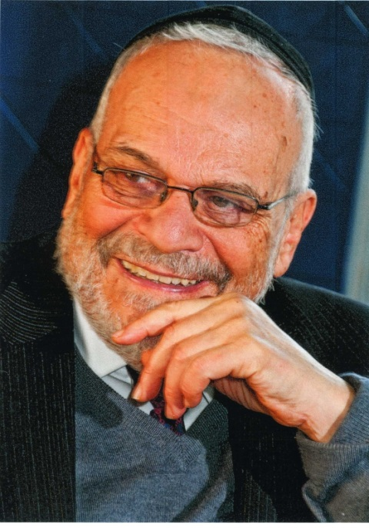

**Rabbi Berel Wein**

The concept of an eternal light in the place of worship is an ancient one derived from the opening section of this week's reading of the Torah. The eternal light represents the unquenchable spirit and resilience of the eternal soul that the L-rd has implanted within human beings. Human life can be taken away but the spirit of life, which is so unique to human beings, seems never to disappear.

In this week's reading of the Torah, we learn that the eternal light must be attended to and nurtured. It requires preparation of the fuel and the kindling of that eternal light by human beings, in this case the descendants of Aaron, the priests of Israel. There was an eternal flame that existed on the altar in the Tabernacle and in the holy Temple.

That flame existed and was kept alive permanently by a miracle of G-d. It existed during the entire time of the first Temple but was one of the miracles that no longer reappeared in the times of the second Temple and thereafter. But the eternal light that was to be lit and maintained on the great candelabra in the building of the Temple was not to be miraculously so endowed. This light required constant human attention and participation.

From this we may derive that there are two forms of eternity in human affairs and history. One is of purely divine origin, miraculous and wondrous, which operates completely independent from human efforts, ordinary laws and rules of nature. The other path of eternity, represented by the likes of the candelabra, is wholly dependent on human participation, care and attention.

Human beings often confuse these two types of eternal light. When it comes to certain matters, mainly spiritual or familial in nature, we rely heavily on miracles that will sustain us and allow us to escape from our difficulties.

Regarding our personal lives, our profession, and our politics, we feel that these areas of human life are totally within our ability and purview to control and shape. However, the Torah teaches us that both forms of eternallight, the miraculous and the one that requires human effort and attention, are with us always.

That is why in the Tabernacle, and later in the first Temple itself the eternal light was represented at one and the same time and in the same place. Miracles do happen, and the guiding hand of the Eternal One is evident throughout the history of the Jews.

But, the old adage that G-d helps those who help themselves is also valid and true. The eternal flame is to be lit by human beings who prepare the fuel and kindle a light through human effort and care. It is this combination of the forces of eternity that unite and guarantee that the light of Israel will never be extinguished.

*Reprinted from this week’s website of Rabbiwein.com*

**The Power of Speech**

**By Rabbi Eli J. Mansour**

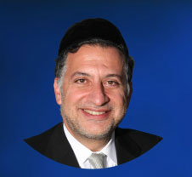

Parashat Tesaveh is the only Parasha in the Torah after the account of Moshe’s birth in which his name does not appear.  In every single Parasha since Parashat Shemot (in which we read of Moshe’s birth), his name is mentioned, as we might expect. Parashat Tesaveh marks the glaring exception.

The Rabbis teach that Moshe’s name was omitted from this Parasha because of an incident about which we read in next week’s Parasha, Parashat Ki-Tisa.  In response to the sin of the golden calf, G-d decided to eradicate the Jewish people and create a new nation from Moshe’s offspring.

Moshe, however, like a captain who refuses to abandon his sinking ship, interceded on the people’s behalf.  He insisted that if G-d destroys Beneh Yisrael, Moshe must be eradicated along with them.  Moshe would not agree to be kept alive if Beneh Yisrael were killed, and he said, “Forgive, please, their sin, and if not, erase me from Your book which You have written” (Shemot 32:32). G-d accepted Moshe’s plea, rescinded His decree and forgave Beneh Yisrael.

Nevertheless, despite G-d’s forgiving Beneh Yisrael, Moshe’s demand of “erase me from Your book” had to be fulfilled, at least to some degree.  A statement made even on condition – especially when made by a Sadik – has a certain power and will be fulfilled, in one way or another.  Hence, even though Moshe hinged this demand on a condition that was not met – as G-d indeed granted Beneh Yisrael forgiveness – it had to be fulfilled.  And for this reason his name was eliminated from a Parasha in the Torah.

Our Rabbis inferred from this omission of Moshe’s name the immense power wielded by human speech.  In Jewish thought, words are not cheap.  They carry a lot of weight and are very significant.  And thus, alongside the obvious prohibition against cursing or speaking with hostility to other people, we must also exercise extreme care regarding the way we speak even about ourselves.

Some people express frustration or disappointment with remarks such as, “I could die,” or “I could kill myself.”  These words must never be spoken, because even if they are said in jest, as an exaggeration, or on condition, they have power and could be fulfilled, Heaven forbid.  As our Sages teach, “Al Tiftah Peh La’Satan” – “Do not open your mouth to the Satan.”  Satan has enough ideas of ways to harm us; we should not be giving up more.

There are several striking examples of this concept in the Humash.  Yaakob told Laban that the person who stole his idols “shall not live” (Bereshit 31:32), and as a result, Rahel, who had taken the idols, died young.

Yehuda declared to Yaakob that he would renounce his share in the next world if he did not bring Binyamin home safely from Egypt.  Although he succeeded in bringing Binyamin back, he was nevertheless denied entry into the next world for 250 years until Moshe Rabbenu prayed on his behalf.  A tongue is soft and looks innocuous, but it can be a very dangerous weapon, even against oneself.

Rav Haim Palachi, the great Rabbi of Izmir, Turkey (1788-1869), once spoke about his righteous grandmother, and described how when she became angry and felt the urge to curse someone, she would exclaim, “Ha’mavet Al Yafrid Benenu” – “Death shall not separate between us.”  She accustomed herself to this exclamation so that her mention of “death” would always be made in a positive context.  Negative words are so damaging that the Sefer Hasidim (Rabbenu Yehuda Ha’hasid, Germany, late 12th-early 13th century) writes that if one lives near people who curse, he must move away.

This is especially important when it comes to parenting.  Unfortunately, many parents speak very harshly when they become aggravated by their children, and make comments such as “I am going to kill you,” “I am going to wring your neck,” and the like.

Besides the emotional damage such comments cause to impressionable children, they are also dangerous, plain and simple.  We must recognize the unique power of words and ensure to speak with care and discretion, so that our words will bring only blessing and happiness, and not, Heaven forbid, the opposite.

*Reprinted from this week’s website of the Edmund J. Safra Synagogue in Brooklyn, NY.*

**Michael Cohen’s Prison**

**Of Choice: Well-Known**

**To Jewish Offenders**

**By Corey Kilgannon**



**The minimum-security camp at the Federal Correctional Institution in Otisville, N.Y., has become an enclave for Jewish white-collar offenders.CreditCreditTom** **Bushey/Middletown Times Herald Record, via Associated Press**

When Michael Cohen, President Trump’s former lawyer, was [sentenced last month](https://www.nytimes.com/2018/12/12/nyregion/michael-cohen-sentence-trump.html?module=inline) to three years in federal prison on fraud charges, he had the right to request any number of prison camps favored by white-collar offenders for their relatively resort-like settings.

But Mr. Cohen chose a shabby, low-slung building 75 miles northwest of New York City, with an antiquated weight room, an uneven tennis court and no swimming pool.

What the minimum-security camp at the Federal Correctional Institution in Otisville, N.Y., does offer is a rarity in the federal prison system: a full-time Hasidic chaplain who oversees a congregation of dozens of Jewish inmates who gather for prayer services three times a day.

“For a Jewish person, there is no place like Otisville,” said [Earl Seth David](http://davidlangner.blogspot.com/2015/12/prison-life-at-otisville.html), 54, a former inmate who attended kosher meals, religious classes and weekly Shabbat services in the prison shul, a shared space where the Torah scrolls are locked up every night.

“As a Jew, there’s no other prison you can get services like that.”

Otisville’s camp has long been the lockup of choice among Jewish white-collar offenders, including Sheldon Silver, the former speaker of the New York State Assembly who was [convicted on federal corruption charges](https://www.nytimes.com/2018/07/27/nyregion/sheldon-silver-sentencing-prison-corruption.html?module=inline). Mr. Silver, who is free on bail pending an appeal, has requested to serve his seven-year sentence at the camp.

Otisville is also one of the closest federal lockups to New York City, making it attractive to non-Jewish convicts as well, including Dean Skelos, the former New York State Senate majority leader who reported to the camp this month to begin his [four-year sentence on bribery and other charges](https://www.nytimes.com/2018/10/24/nyregion/dean-skelos-sentenced-prison-trial.html?module=inline). Mike “The Situation” Sorrentino, the reality star from “Jersey Shore,” recently [arrived](https://twitter.com/ItsTheSituation/status/1084967844079718405) at the camp, to serve a sentence for tax evasion.

The camp — which sits near Otisville’s main prison, a much larger medium-security lockup — has a population of about 120 inmates, including drug dealers and other street-level criminals with good prison records.

But most inmates are Jewish — many of them orthodox and Hasidic — and many are doctors, lawyers, accountants and businessmen who committed fraud.

A few also have backgrounds as ordained rabbis and, once inside, some assume a spiritual leadership role. Inmates periodically hold an informal vote to elect a “gabbai” to run the shul, which is currently led by a Hasidic man from Williamsburg, Brooklyn, who is locked up for arson and corporate fraud.

There is never a problem reaching a minyan, or a quorum of at least 10 Jews needed to hold services, at the camp, where inmates live communally in dorm-style housing units and sleep in bunk beds.

Orthodox inmates wear fringed vests known as zizit under their green prison uniforms. Prison work shifts are scheduled around daily prayer sessions and Sabbath observances. Before many holidays, the men are taken by prison bus to a nearby town for traditional mikvah baths.

The list of prominent people at Otisville reduced to doing menial prison jobs is long.

Ken Starr, a money manager who siphoned millions from his celebrity clients, wiped down mess hall tables during his stay, and Walter Forbes, an executive charged with securities fraud, mopped floors, according to former inmates. Hassan Nemazee, an investment banker and political bundler associated with the Clintons, cleaned the bathrooms while serving time for bank fraud.

The federal prison camps are not available to certain offenders, like those with sentences of more than 10 years. So Bernie Madoff, who received 150 years for his Ponzi scheme, had his request for Otisville denied.

Messages left for prison officials at Otisville were not returned, and Bureau of Prisons officials would not provide any specific information on Jewish services at the camp.

Over the years, federal officials have “sort of carved this place out as a special location to put Jewish inmates,” said Benjamin Brafman, a prominent defense lawyer who has represented numerous defendants who have requested Otisville.



**Michael Cohen, President Trump’s former lawyer, has asked to serve his sentence on federal fraud charges in Otisville.CreditStephanie Keith for The New York Times**

There are kosher vending machines in the visiting room. The prison commissary sells skullcaps for $6 and offers a kosher selection that includes matzo, gefilte fish, rugelach and seltzer.

“Hey, it’s not Zabar’s, and it’s a little overpriced,” said one former inmate, [Lawrence Dressler](https://larrynoodles.com/), 52. “But what do you want? It’s prison.”

While kosher meals — three a day — come in prepackaged trays, inmates make Sabbath and holiday meals from scratch in the small kosher kitchen, to be eaten in the shul on tables with bedsheets as tablecloths.

“You feel like you’re back home, singing Shabbos songs with the other inmates,” Mr. Dressler recalled. “The camaraderie helps take you away from the place for a little while.”

With limited ingredients, inmates devise innovative ways to make Passover Seder meals featuring kosher chicken, handmade matzo, horseradish and grape juice.

They often repurpose food from prepackaged meals and supplement it with food smuggled out of the kitchen or supply room, said Jeff Weisman, 46, who served time in the camp on mail fraud charges and worked in the kosher kitchen.

For Sukkot, inmates assemble a large wooden sukkah shelter outside to sit and eat meals in.

The camp has little in the way of fences or bars, and for observant Jewish inmates, it is “the closest thing you have to nirvana in a federal prison,” said [Joel A. Sickler](http://justiceadvocacygroupllc.com/), a criminologist and consultant who advises mostly white-collar offenders facing prison sentences.

But Mr. David said it was no picnic.

“That Club Fed stuff is a myth,” said Mr. David, a lawyer from Manhattan who served four years in seven federal prisons, including Otisville, on immigration fraud charges. “There’s no swanky pool. You’re up at 6 a.m. every morning for the inmate count. The guards can raid your bunk at any time and you get zero rights, zero privacy. You’re sleeping next to 100 snoring men. So being able to practice your faith helps you survive.”

Mr. David added: “The religious services always come first. With other prisons, it’s just the opposite.”

Many inmates “knew the Talmud inside and out,” said Mr. Dressler, a lawyer in New Haven who served 18 months in Otisville for mortgage fraud.

They often conducted religious classes and gained inmate followings, as did a Hasidic rabbi from Brooklyn who got caught up in mortgage fraud before the 2008 housing market crash.

Then there was the Syrian rabbi from Deal, N.J., who was involved in a money-laundering scheme and whose parables were particularly enjoyed by Russian Jewish inmates from Brighton Beach, Brooklyn, who were in prison for health care fraud.

Another spiritual leader was Naftali Tzi Weisz, the grand rabbi of the Spinka sect of Hasids in Brooklyn, who was locked up for a [charity donation scheme](https://www.nytimes.com/2007/12/20/nyregion/20rabbis.html?module=inline).

A lawyer for Mr. Cohen did not respond to messages, and it is still uncertain whether Mr. Cohen will wind up at Otisville. The federal judge in his case has agreed to recommend he be assigned there, but the decision is ultimately made by the Bureau of Prisons, which is under the Department of Justice.

But perhaps more than that, Mr. Sickler said, the high-profile nature of Mr. Cohen’s case could hurt his chances of being sent to Otisville, simply because federal prison officials might want to avoid giving the impression that inmates get to automatically choose their own prison.

Mr. Dressler said Otisville inmates would probably ostracize Mr. Cohen at first, because he provided inside information about Mr. Trump, and therefore qualifies as a rat in cellblock circles.

“It’s part of the code,” Mr. Dressler said. “A lot of inmates are in there because people testified against them. Half the chatter in the camp is about rats, so he’ll have to listen to that a lot.”

*Reprinted from the January 22, 2019 website of The New York Times. A version of this article appears in print on Jan. 22, 2019, on Page A17 of the New York edition with the headline: Cohen’s Prison Request: Otisville, the ‘Nirvana’ for Jewish Offenders.*[*Order Reprints*](http://www.nytreprints.com/)*|*[*Today’s Paper*](http://www.nytimes.com/pages/todayspaper/index.html)*|*[*Subscribe*](https://www.nytimes.com/subscriptions/Multiproduct/lp8HYKU.html?campaignId=48JQY)

**The Steinsaltz Humash**

**By Daniel Keren**

“The Steinsaltz Humash: Humash Translation and Commentary”, Commentary by Rabbi Adin Even-Israel Steinsaltz, Steinsaltz Center, published by Koren Publishers Jerusalem, 1311 pages, 2018.)

The Jewish people are known throughout the world as “the people of the Book,” and we don’t just take our books at face value. All of our important books have over the millennium been the subjects of countless thousands of commentaries. In each new generation, a fresh need to understand the words of the Torah renews itself, while certainly not eliminating the value of studying the precious explanations of previous Torah giants.

Rabbi Adin Even-Israel Steinsaltz is perhaps one of the most noted and of course controversial Torah scholars of the past half century. Wikipedia describes Rabbi Steinsaltz as “a teacher, philosopher, social critic, and spiritual mentor, who has been hailed by Time Magazine as a “once-in-a-millennium scholar [who] has devoted his life to making the Talmud accessible to all Jews.” [And that endorsement from a non-Jewish source certainly raised eyebrows in certain more traditional Orthodox circles of the Jewish Torah world.]

Rabbi Steinsaltz was born to secular parents in Jerusalem during the British Mandate period in 1937. While studying rabbinical studies in a yeshiva, he at the same time took courses in mathematics, physics and chemistry at Hebrew University. He is today best known for his decades-long project beginning in 1965 to translate the Babylonian Talmud into modern Hebrew. Since then scholars under his direction have also translated his Hebrew translations and commentaries of the Talmud into English, French. Russian and Spanish.

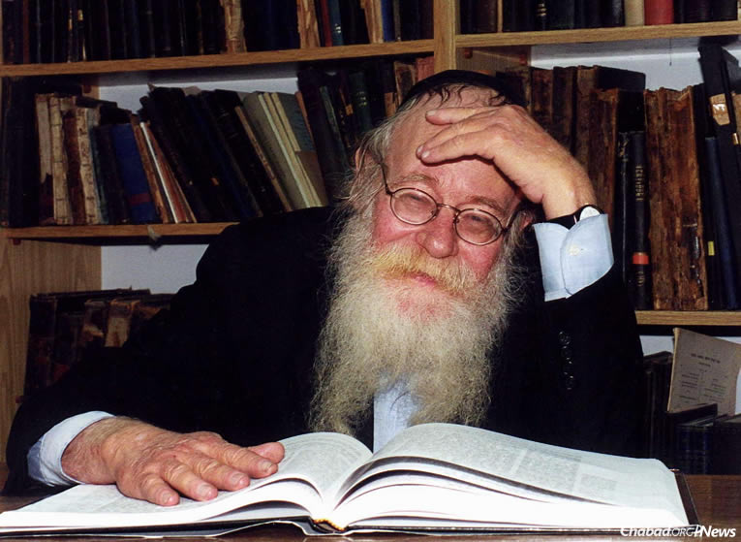

It is almost three years since Rabbi Steinsaltz suffered a very serious stroke that has ended his illustrious lectures and new writing projects that attracted bright minds from all circles of Israeli society. Books, including this Steinsaltz Humash have been carefully prepared from his unpublished manuscripts or already published Hebrew seforim (books) by the Steinsaltz Center that is now headed by the author’s son – Rabbi Menachem Even-Israel.

To better understand how the father communicates his thoughts on new projects like the English translation of the Steinsaltz Humash, you might want to google “In the Shadow of Rabbi Adin Steinsaltz” by Molly Resnick that was published in the November 7, 2018 edition of The Jewish Press.

In a special Introduction by the translators at the beginning of the Humash, the goal of the project is explained: “The English translation of the Steinsaltz Commentary on the Humash includes a completely new translation of the Humash based on Rabbi Adin Even-Israel Steinsaltz’s Hebrew commentary. Translation is necessarily an act of interpretation. In general, we have done our best, at Rabbi Steinsaltz’s behest, to stay as close as possible to the original Hebrew verses so that the English reader will encounter the complexities of the text directly…

“Our goal throughout has been to produce a translation that is true to the original Hebrew text and commentary, yet at the same time is readable and accessible to a broad range of readers, from those who are familiar with Hebrew and seek to deepen their understanding of the Torah and those who will gain access to the text only by reading it in English.”

In the Introduction by the Hebrew Editors, an important point was also made: “It must be stated that even when written without qualification, the interpretations offered [by Rabbi Steinsaltz] are not meant to be seen as authoritative. They are no more than suggestions, occasionally novel ones, which are compatible with the simple meaning of the text and which speak to the average reader. There are no systematic exegetical considerations behind the decision to adopt any particular interpretation.”

This coming Shabbat is Parashat Teruma and the Steinsaltz Humash begins with the heading “The Commandments to Construct and Consecrate the Tabernacle and Its Utensils.” There are many color photos and illustrations of the subjects mentioned or alluded to, such as a ram, a gum Arabic tree, a dugong, a Murex brandaris and Murex trunculus that Rabbi Steinsaltz believed were the sources for some of the material needed for the items used in constructing the Tabernacle in the Wilderness.

The original Hebrew pages of the Steinsaltz Humash contain just the Rashi commentary. Every English translation contains commentaries based on Rabbi Steinsaltz’s original explanations of the Hebrew verses (pasukim.) In addition to the verse by verse commentaries, at the bottom of many of the pages are additional explanations that are offered as background or discussion options.

Parashat Teruma and the following parashats Tetzaveh, Ki Tisa, Vayakhel and Pekudei which complete Sefer Shemos (the Book of Exodus) are quite technical and often repetitive descriptions of how the Jews were commanded by G-d to construct the Sanctuary, create the various utensils (i.e. the Menora or Candelabrum) and how they were to prepare the special clothes for the Kohanim and sanctify the new class of Jewish priests.

An example of one of Rabbi Steinsaltz’s discussion points in an explanation of the words “On the west” (Shemos 26:22) “According to many traditions, the direction east is considered sacred. However, the descriptions of the Tabernacle indicate that its west side possessed greater sanctity. In contemporary Judaism, emphasis is often placed on the east, since the Land of Israel was historically east of the Jews living in Europe, who therefore would always pray eastward.

“However, both in the Tabernacle in the wilderness and in the Temple in Jerusalem, the Holy of Holies was located in the west, while the east served as the entrance for worshippers facing westward toward the divine abode (Bava Batra 25a, Shemot Rabba 2:2)

“The Steinsaltz Humash” is available in Jewish and general bookstores or by contacting the publisher by calling (203) 830-8508 or clicking korenpub.com

*Reprinted from the February 8, 2019 edition of the Jewish Connection.*